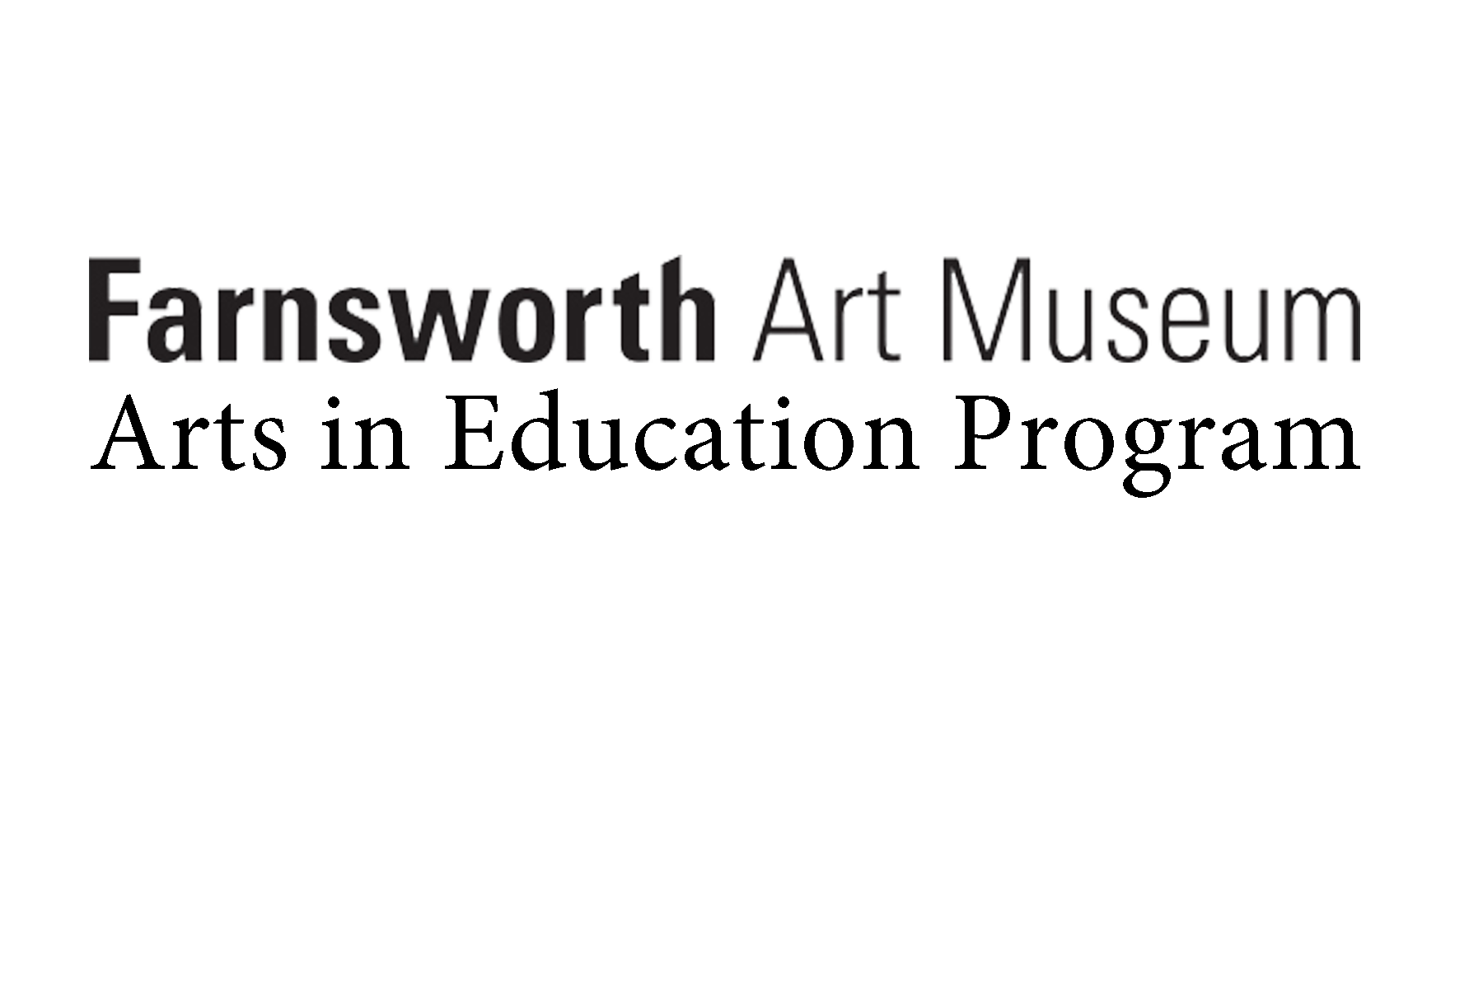

Thursday, August 23 Educator Workshop, 10:00 am – 4:00 pm at the Gamble Center

*Tuesday, September 4 Classes Start*

Friday, September 14 Deadline: Classroom Rosters Sent to Ed. Assistant

Deadline: Permission Slips *(bring to first field trip)*

September 11-13, 17-21 Andrea In-School Introduction Lessons

September 24 – October 4 Foundation Field Trips, 9:45 am – 1:15 pm at Farnsworth Museum

September – October Expeditionary Field Trips

November – December In-School Curricular Connections

Preparatory Art Lessons (in Art Room)

*December 24 – January 1 Holiday Break*

January – February Art-Making in School

Museum Gallery Visits & Studio Sessions at Farnsworth Museum

Friday, March 1 Deadline: Student Project Artwork and Presentation Materials to Farnsworth

Deadline: Educator Lesson Plans for Presentation

Sunday, May 19 Stories 2019 Exhibition Opening

11:40 am – 12:30 pm Student Performer Rehearsal at the Strand Theatre

12:40 – 1:00 pm Red Carpet at the Strand Theatre

1:00 pm – 2:00 pm Opening Ceremony at the Strand Theatre

2:00 pm – 5:00 pm Exhibition Opening & Reception at Farnsworth Museum

Thursday, May 23 Stories Educator Focus Group, 3:00 – 5:00 pm at the Gamble Center

Friday, May 31 Deadline: Stories Evaluations and Educator Documentation

Stories of the Land and Its People

Schedule 2018-2019

Farnsworth Art Museum | Andrea L. Curtis, *Education Program Manager*  | Arts in Education Program | 2018-2019